Setting Up and Testing your Local Python Installation
August 2026 Immersive Python Workshop

Welcome! This guide will walk you through the process of installing the software that you need to have running on your computer in order to fully participate in the Immersive Python Workshop. This process also includes an automated process for testing your Python installation so that you can verify that you have Python and VSCode working successfully. An internet connection is required for this short test. The overall installation process should take about 15-30 minutes. If you are following this guide during the workshop and have a question, please raise your hand and a workshop helper will come by to talk with you and provide assistance. If you are following this guide outside of the workshop and you run into a problem, please contact rds@austin.utexas.edu to explain your issue and request assistance.

Setting Up and Testing your Local Python Installation 1
Step 1: Python installation and set up 1
Step 2: VSCode installation and set up 2
Step 3: Create a new project folder, set up a virtual environment, and install required packages 3
Step 4: Download the installation test Python file 5
Step 5: Install Python packages in your virtual environment 5
Step 6: Run the script to test your installation 5
Step 7: Install GitHub Desktop 6
Step 8: Make sure you can run Git 6
Troubleshooting 7
Windows 7
MacOS 9
Virtual Environment Issues 10

Step 1: Python installation and set up
- You might already have Python on your computer since it comes pre-installed with MacOS and comes bundled with certain software applications (e.g., QGIS). You may have also already previously completed a manual installation of Python. You should not use your bundled OS Python installation or Python installation that is a dependency of a particular software application; instead use a dedicated Python installation for your coding projects.
- If you have already manually installed Python previously and can run it using python in your Command Prompt (Windows) or using python3 (MacOS), skip to step 2, otherwise continue following the directions below to complete Step 1.
- To install Python, visit www.python.org/downloads/ and download the latest stable release while avoiding pre-release versions and older versions (e.g., the best option would be 3.14 in the example below)
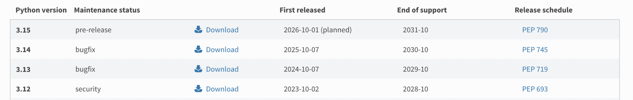
- Run the Python installer that you have downloaded. If you are installing Python on Windows, make sure that you check the box for “Add Python to environment variables” so that you can use the python command in your Command Prompt.
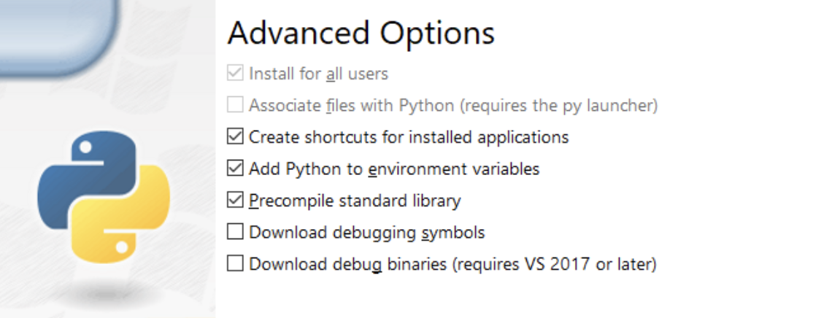
- Check that you can run Python successfully
  - In Windows, open your Command Prompt and type python, then run the command
  - In MacOS, open the Terminal and type python3, then run the command
- If these commands are run successfully, you should see the Python version listed and then see >>> which indicates you are now working inside of the Python interpreter. If everything looks correct, you can type exit() and then press return to exit out of Python, or you can just close your Terminal or Command Prompt window.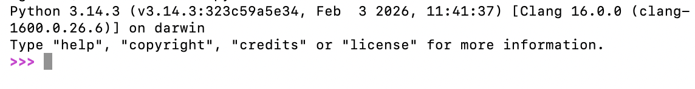

Step 2: VSCode installation and set up
- Once Python is successfully installed, you should next make sure that you have the VSCode code editor installed and configured correctly. VSCode is a popular application that is used to create and edit text and code in a number of different programming and markup languages, including Python.
- If you do not already have VSCode installed, you can visit https://code.visualstudio.com/ to download the installer.
- If you have never run VSCode before, you will need to click through some welcome messages, etc. If it asks you any questions, the default settings should be fine.
- When you open VSCode for the first time, you will need to install the Python extension in order to run Python files. On the left sidebar, you should see this icon for the Extensions:
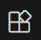
- If you don’t see this, click on View > Extensions

- Search ‘Python’; many options will show up, but it should be the first or second one that is just called ‘Python’ (nothing after it). If you click on it, you should see this:
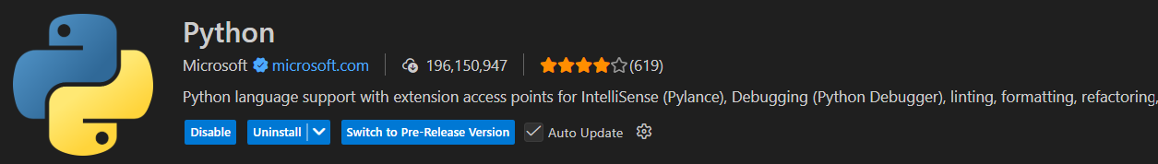

(Note: you will not see the same blue boxes unless you already have the extension installed)

- It may require you to also install some accessory extensions - this is fine as long as you install the official Python extension from Microsoft - make sure there is a blue checkmark next to it and about 230,000,000 downloads.
- To verify that the extension is installed correctly, you can create a new simple Python file and try running it with the Python extension. Before creating a Python file, we will first create a new folder to manage code you will be working with during the workshop. Using your Finder (MacOS) or File Explorer (Windows), create a subfolder called ‘immersive_python_workshop’ in your Documents folder.
- In VSCode, click File > Open Folder and then select the new ‘immersive_python_workshop’ folder you just created per the instructions above
- Once you have opened the ‘immersive_python_workshop’ folder in VSCode click the icon showing a file with a plus sign that is highlighted in green below and create a file named example.py
- 
- In your example.py file, write a simple print statement like the example below and then click the play button highlighted in green below. If the Python extension is working correctly, you should see a new terminal window pane pop up in VSCode that shows the code being executed and successfully prints “success!”
- 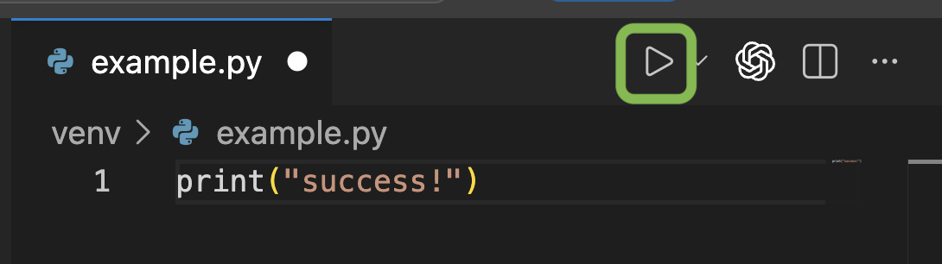
- Now, it is necessary to make sure you are working in a virtual environment and then you can install Python packages for the practice project that you will be working on during this workshop.

Step 3: Create a new project folder, set up a virtual environment, and install required packages
- Click Terminal > New Terminal to create a new Terminal window inside of VSCode
- In your VSCode terminal window, type the command below that corresponds with your operating system. This command will create a new virtual environment folder named venv in your ‘immersive_python_workshop’ folder:

MacOS | Windows
- Type in the command below:  - python3 -m venv venv | - Type in the command below:  - python -m venv venv

- If the command is successful, your VSCode Explorer view on the left side of your VSCode window should look like the example below when you expand the venv folder to check its contents (if you don’t see the Explorer pane, click on View > Explorer). If you receive an error message that mentions a “Keyboard Interrupt” or see the venv folder has been created but notice some files are missing compared to the example below, then try re-running the exact command listed above for your operating system. Sometimes, the command might need to be done a few times to get everything set up correctly.
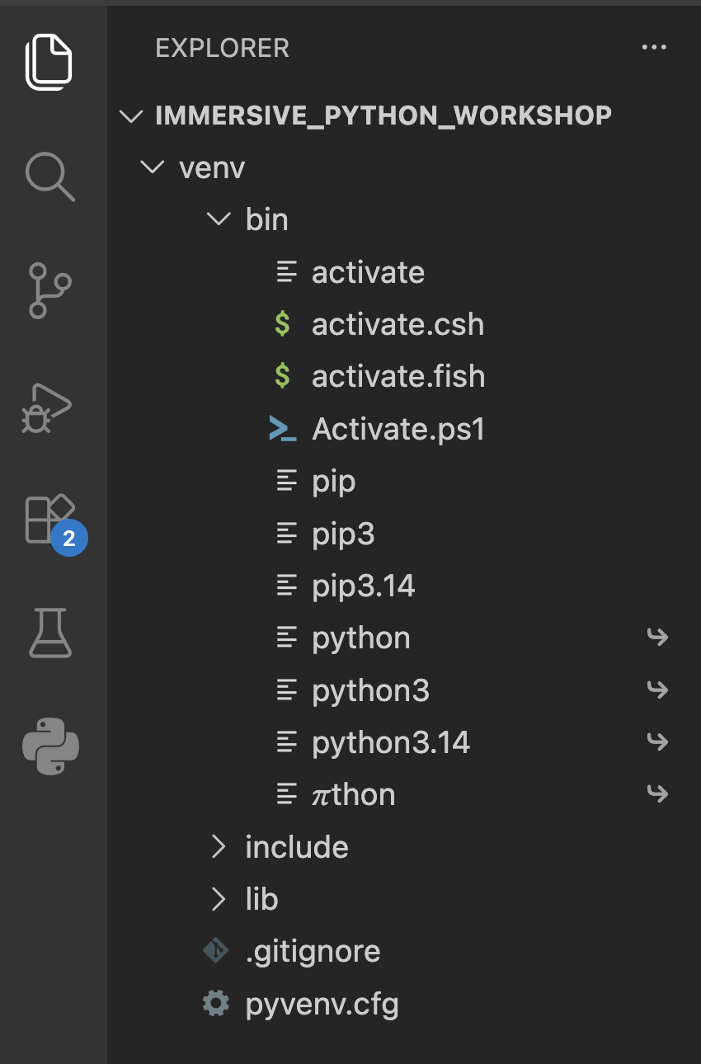
- Once your set up looks like the example above, your virtual environment has been successfully created but it is not yet necessarily activated. In order to make sure it is active, close your VSCode terminal window by clicking the X button in the top right of the window, and then go to Terminal > New Terminal to open a new terminal window in VSCode. When you do this, wait about ten seconds and you should notice that your terminal will update itself and add ‘(venv)’ in front of the prompt message indicating your current working directory. The ‘(venv)’ designation indicates that it is using the virtual environment defined in the venv folder you created. If you see (venv) as shown in the screenshot below, you are now ready to move to the next step, but if you do not see that, check the bullet point below for instructions on how to manually trigger activation of the virtual environment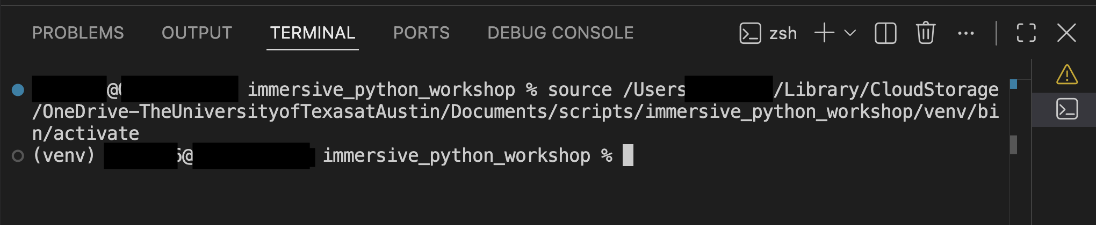
- To manually activate the virtual environment and get the ‘(venv)’ prefix to appear, use the command below that corresponds to your operating system by typing it in your VSCode terminal and clicking return on your keyboard.
MacOS | Windows
- Type in the command below:  - source venv/bin/activate | - Type in the command below:  - If using cmd: venv\Scripts\activate.bat  - If using PowerShell: venv\Scripts\Activate.ps1

Step 4: Download the installation test Python file
- Now that Python, VSCode, and your project virtual environment should all be set up successfully, we will prepare to test that everything is actually configured as needed for the workshop. At this point, go to GitHub and download the Python script for testing your software installations at https://github.com/utlibraries/workshop-materials/blob/main/immersive-python-workshop-2026-8/python-installation-test-aug2026.py
  - To download the Python script to your computer, click the download button circled in green in the screenshot below. Put this file into the ‘immersive_python_workshop’ folder that you created earlier.
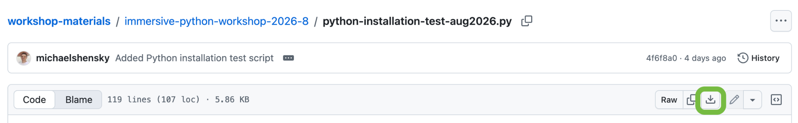

Step 5: Install Python packages in your virtual environment
As part of the test we will be running in the next step, we will be checking whether your Python is able to correctly detect a module that is not part of the default Python standard library: requests.

- Now that you are in your virtual environment, install the requests module like so. Note: if (venv) is not showing at the start of your active prompt line in the VSCode terminal, the packages below will instead be installed “globally” meaning that they will be installed for your base Python installation and used by default by any project that is not using its own virtual environment.

MacOS | Windows
- Type in the command below:  - python3 -m pip install requests | - Type in the command below:  - python -m pip install requests

A lot of lines of code will appear quickly. If the installation is complete, you will see a final message indicating as much. If you see an error message, or the command fails, please reach out, as this likely indicates an issue with your Python installation.

- Now that you have installed requests, use the same approach to install the pandas package

Step 6: Run the script to test your installation
- In order to run the script, look in the top right of the VSCode window:

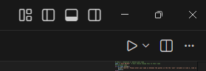

- Click the play (triangle) button to run the script. You will see a prompt appear in the Terminal window at the bottom that asks for your name - type it and hit the ‘Enter’ key
- The script will show you different messages based on whether or not the step was successful, but it will complete either way and fill out information in a private Google Form so that we can log a record of where you encountered problems.
  - FAQ: if you do not see the triangle button, it means you did not install the extension for Python; if you just installed it, you likely need to exit out and reopen the program.

Step 7: Install GitHub Desktop
- If you have not previously installed GitHub Desktop, visit https://desktop.github.com/download/ and download the correct version for your operating system.
- Run the installer. Once installation is complete, open GitHub Desktop.
- When you open GitHub Desktop for the first time you may be prompted to log in with your GitHub account. If you are not prompted to sign in, you can go to File > Settings > Accounts to sign in. If you do not already have a GitHub account, visit https://github.com/ and create a new account that you can then use to sign in to GitHub Desktop.

Step 8: Make sure you can run Git
- If you are on a Windows PC, check that everything is working as expected with Git by opening a Command Prompt window and type git. If Git is installed and set up correctly, you should see an explanation of allowable Git commands show in the Command Prompt response. If git is not installed or not accessible via the Command Prompt, visit https://git-scm.com/install/windows to download the correct version for your computer. The Git for Windows/x64 Setup is likely to be the correct version for most Windows computers. Once you have downloaded the installer, run it to begin the installation process. The Git install process will present you with a number of different configuration screens since Git is highly customizable. It is best to accept the default settings unless you feel very certain you understand what changing the default would do and you are sure you want to have Git configured in that particular way. Note: if you are presented with options for Adjusting your PATH environment, make sure that you are selecting the option shown highlighted in green below which will allow you to run Git from your Command Prompt. Once the installation finishes, open a new Command Prompt window and try using the git command again to confirm that everything is working as expected.
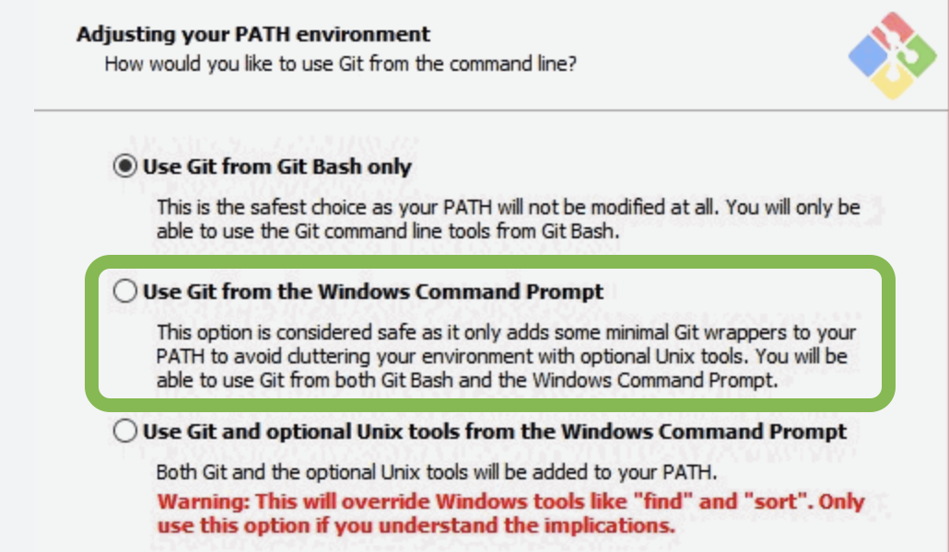

- If you are on a Mac, you can test to see if you already have Git installed and working by opening a Terminal window and submitting the git command.
  - If Git is installed, you should see an explanation of allowable Git commands appear in the Terminal response.
  - If Git is not yet installed and configured properly, macOS will recognize that Git is missing and show a pop up prompt indicating that "The git command requires the command line developer tools." If you see this message you can click Install to begin the automated setup.

Troubleshooting

Windows Python Install

Problem: Python cannot be called successfully from the Command Prompt

Description
- When you try to run Python from the Command Prompt, for example to check your pip module by running python -m pip, you do not see the expected output but instead encounter one of see the following:
  - You receive an error message in the Command Prompt stating that 'python' is not recognized as an internal or external command
  - The Microsoft Store will automatically open because Python wasn’t found and your computer assumes you want to find new software to download

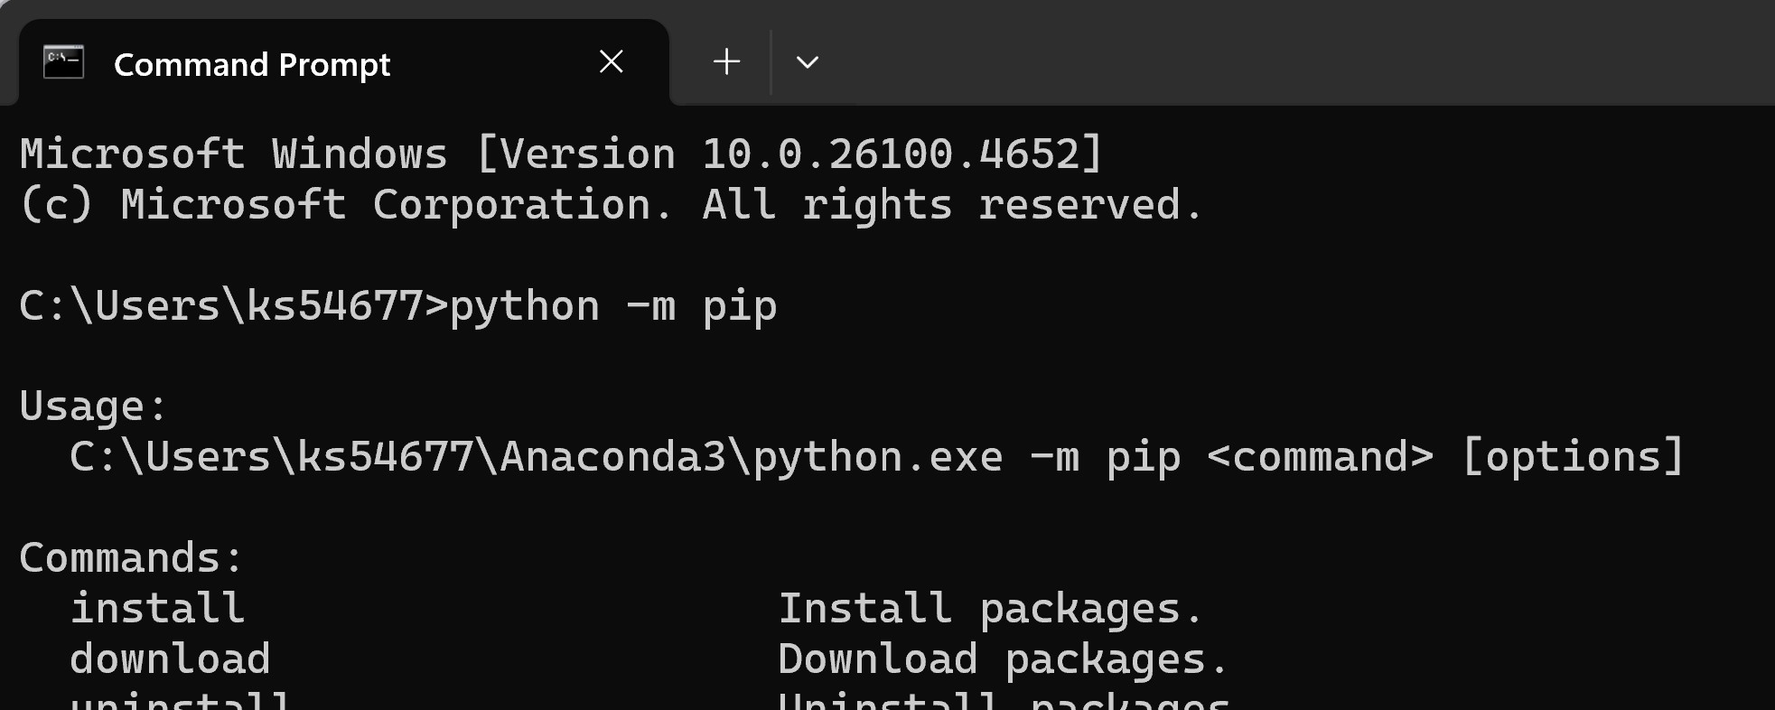
Solution
- This problem can occur for two primary reasons: either Python is not installed or it was installed but it was not added to your path environmental variables so the command prompt does not recognize that the python command should point to the Python interpreter
- First, make sure you have installed Python. If you are not sure, go to the official Python website at https://www.python.org/downloads/, download the correct version for your computer, and run the installer.

- Click the Download Python button for the latest version.
- Once downloaded, note the location where the installer was saved.
- Run the installer and check the box that says “Add Python to PATH” before clicking Install Now.

Problem: Python script cannot be run using the play button in VSCode on your PC
If you get an error like “Python not found” or “Interpreter not selected,” follow these steps:
- Click the gear icon (⚙️) in the bottom-left corner of VS Code.
- Select Settings.
- In the search bar, type:
  - Default Interpreter Path
- Paste the full path to your Python executable.
  - To find your path, go to File Explorer
  - Located where Python is downloaded
  - Copy Path
  - It should look something like: C:\Users\YourUsername\AppData\Local\Programs\Python\Python312\python.exe

MacOS Python Install

Problem: Python script cannot be run using the play button in VSCode on your Mac

Description
You get an error like “Python not found” or “Interpreter not selected,” when you try to run a Python file in VS Code,

Solution
Follow these steps:
- Click the gear icon (⚙️) in the bottom-left corner of VS Code.
- Select Settings.
- In the search bar, type:
  - Default Interpreter Path
- Paste the full path to your Python executable.
  - To find your path, go to File Explorer
  - Located where Python is downloaded
  - Copy Path
  - It should look like: /usr/local/bin/python3/Users/eid/

- 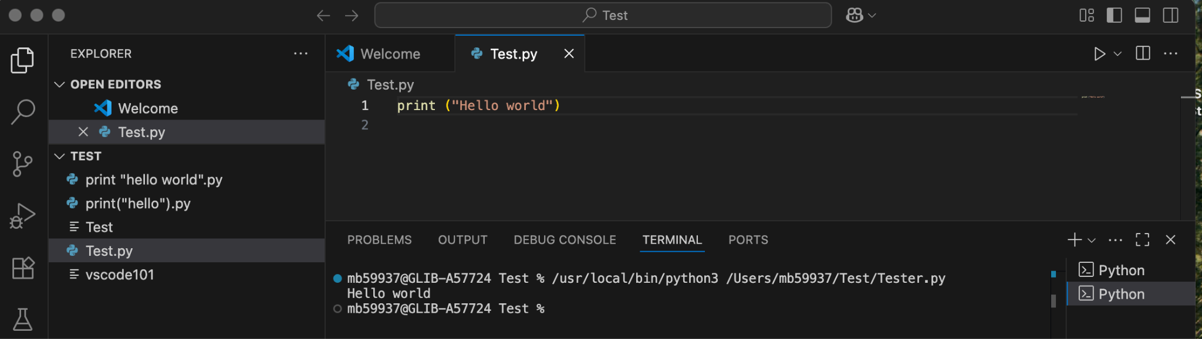
- If it shows Hello world in the terminal part of the screen, it’s properly installed.
If you are still having trouble, make sure that you are using the Z Shell for your VS Code terminal. On the right side of the terminal you should see zsh if you are using a Z Shell terminal. If you see something other than zsh, click the + above your list of open shells and select the zsh option to create a new terminal shell session.
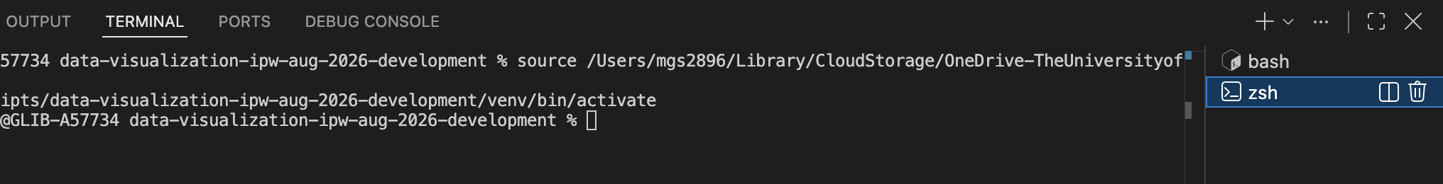
See https://support.apple.com/en-us/102360 for information about using Z Shell as the default sheel on your Mac.
  - Make sure you have bash_profile or a .zshrc file
  - This is where we can store the environment variables or files

Virtual Environment Issues
Check to make sure you are in the correct folder
Your virtual environment must be activated from the folder in which it was created. If you are in the Downloads folder but created the virtual environment in Documents, for example, then the environment will not be detected when you try to activate it.
- In your terminal, use the cd command to move to the correct directory. You may need to go up a level before changing folders. If your Documents and Downloads live at the same level in your folder hierarchy, for example, and you are trying to move from Documents to Downloads, you cannot directly jump to Downloads without moving up a level first, as the Downloads folder is not contained within the Documents folder.
  - You will be able to see which directory you are in within your terminal, as it will be listed right before your cursor like so:
    - 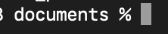
  - To move up a level, type cd .. and hit enter. The “..” means to move up a level in your folder hierarchy.
  - Now, you can move into Downloads by typing cd downloads.

Check to make sure your virtual environment is active
If you installed modules in your virtual environment that are showing as no longer available, make sure you correctly started your virtual environment:
Mac:
    - source venv/bin/activate
Windows:
    - If using Command Prompt: venv\Scripts\activate.bat
    - If using PowerShell: venv\Scripts\Activate.ps1
- Your virtual environment is now active, and you should see a “(venv)” at the start of each new line in your terminal/command prompt to indicate this:
  - 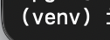

Check that you typed the correct name of your virtual environment
Your virtual environment can be named whatever you like, so make sure you typed the name correctly when trying to activate it. You can check the name by looking at the folder for the virtual environment in your computer’s file directory.

